Pool cleaning –
Chemicals:
BLU52 Big Easy Multi-Functional Pool Floater 1.6kg
R179.99
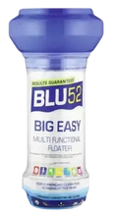
HTH Floater+ Chlorine Pool Cleaner 1.6kg
R189.99
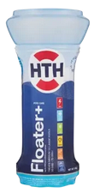
HTH Pace Stabilised Chlorine Pool Floater 1.5kg
R149.99
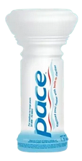
HTH Mineralsoft Granular+ Chlorine 15kg
R799.99
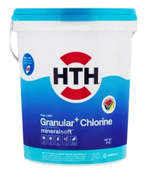
HTH Mineralsoft Granular+ Chlorine 4kg
R279.99
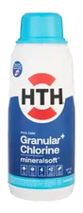
HTH Green Algaecide Micro 1L
R159.99
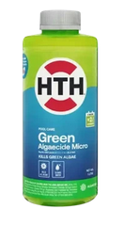
Pool Magic Pool Stabiliser 1.2kg
R119.99
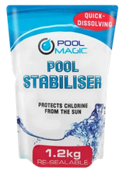

HTH Super Shock It Pool Treatment 600g
R99.99
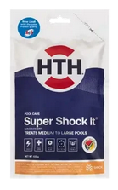
BLU52 Clear Shock Pool Treatment 500g
R69.99
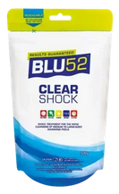

HTH Pool Care Stabiliser 1kg
R129.99
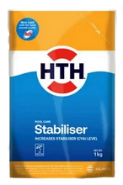
BLU52 Pool Stabiliser Chemical 1kg
R119.99
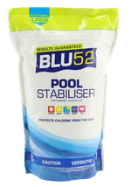

HTH Metal Remover 1L
R149.99
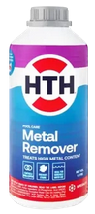
HTH Stain Lift & Prevent 1kg
R159.99
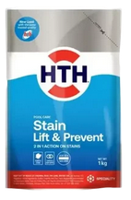
HTH Ultra Clear Algaecide 2L
R149.99
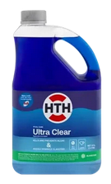
HTH Green Algaecide 2L
R159.99
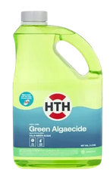
Testing:
HTH Early Warning Test Strips 25 Pack
R129.99
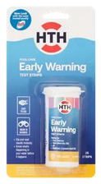
HTH 3-in-1 Test Kit
R179.99
